Thursday, August 22, 2024

Mr. Rob Pope

U.S. Environmental Protection Agency - Region 4

61 Forsyth Street, SW

Atlanta, GA 30303

RE: Public Comment Regarding the U.S Environmental Protection Agency’s Interim Early Action Proposed Plan for Operable Unit 2 at the LCP Chemicals Superfund Site

Dear Mr. Pope,

I am writing to you today to share comments on the U.S Environmental Protection Agency’s (EPA) Interim Early Action Proposed Plan for Operable Unit 2 (OU2) at the LCP Chemicals Superfund Site (Site).

[Please personalize this section including information about 1) why protecting and restoring our environment is important to you, and 2) why it is important for hazardous waste to be appropriately managed in our community]

My specific comments on the proposed plan are as follows.

1. Generally, I am supportive of the implementation of In-situ Chemical Sequestration (ICS) remedial alternative as long as the results of the anticipated pilot studies are clearly communicated to the community and the remedy is proven to be effective in eliminating risks to human health and the environment.
2. EPA needs to provide regular updates to the community, preferably in a hybrid setting and no less than once a year, throughout the remedial process (before and after ICS pilot studies, before and after ICS injection network installation and injections).
3. The installation of a multi-layer hazardous waste-type cap would be more protective of human health and environment than only a soil cover. It reduces infiltration of precipitation into underground wastes and also enhances the redevelopment potential of the Cell Building Area.
4. The EPA needs to address the observed Elemental Mercury in shallow soil north of the Cell Buildings Area either through removal or the addition of injection wells (see image below, Source: Source: Figure 6-1 in FFS Report).

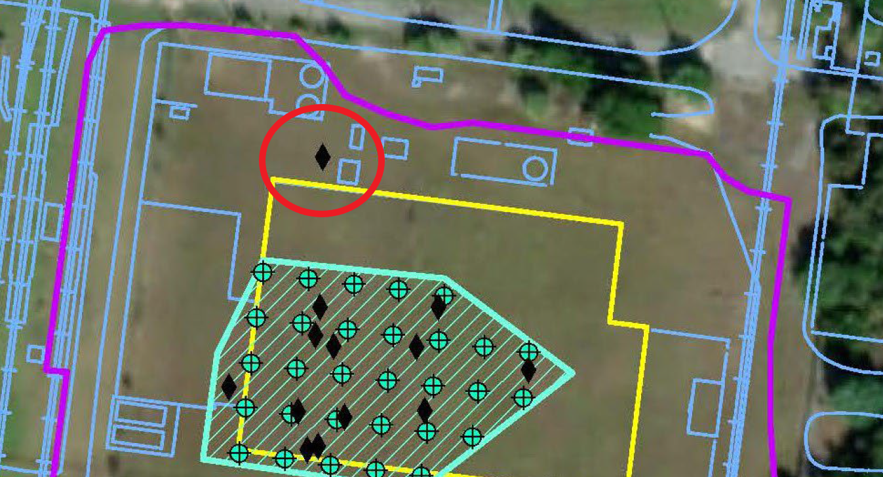

1. The current plan must eliminate risks to human health and the environment based on the current zoning of the property (industrial).

I support the EPA moving forward with the proposed cleanup action with the consideration of the comments included here. Thank you in advance for your consideration of these comments, and I look forward to additional opportunities for public participation in the future.

Sincerely,

FIRST AND LAST NAME:

MAILING ADDRESS:

CITY, STATE ZIPCODE: